Name: Merkis Casado______ Period: __4__
Research Form: Romeo and Juliet Project
Directions: In this project, you will apply the themes and issues within Romeo and Juliet to modern life and work on solutions to age-old problems that are presented in the play, such as:
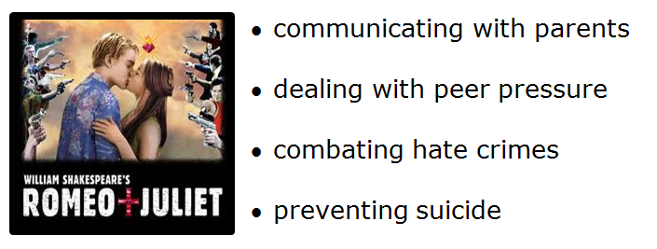
This form helps you to keep track of your resources as you research the current needs of our community and determine a course of action. When completing your accompanying products (brochures, presentations, digital stories, Web sites, and so forth), the following are the minimum requirements for research:
- You must consult at least five resources from completely different sources (not just different pages from the same main Web site).
Use this form as you research—both to help you keep track of good ideas as well as to document that you are meeting the minimum research requirements of the project. This form is to be turned in with your final project. See completed example at end of this document.
Web Site/Printed Material Name:  CMHA-Canadian Mental Health Association | From this site, I will  Use quotes  Use statistics/charts/images  Put info into my own words  Consult for background info  List as a resource for info
Author/Organization:
CMHA-Canadian Mental Health Association
Web Site Address or Publisher and Page #:
http://www.cmha.ca/bins/content_page.asp?cid=3-101-102
Date Published/Updated:
Copyright © 2012
This is a research-worthy site because…
it is a good resource for information about preventing suicide.
Summary of Content that will be used:
This website is about an association helping people that don’t know what to do like situations about suicide which a mental health situation.

Web Site/Printed Material Name:  DBSA-Depression and Bipolar Support Alliance | From this site, I will  Use quotes  Use statistics/charts/images  Put info into my own words  Consult for background info  List as a resource for info
Author/Organization:
DBSA-Depression and Bipolar Support Alliance
Web Site Address or Publisher and Page #:
http://www.dbsalliance.org/site/PageServer?pagename=crisis_suicide_suicide&gclid=CLK5y-7hna8CFasDtgodyzzQdA
Date Published/Updated:
2006
This is a research-worthy site because…
This website is good for helping people with depression.
Summary of Content that will be used:
This website is about an alliance helping people with depression and bipolar problems to get them situation.

Web Site/Printed Material Name:  CDC-Center for Disease Control and Prevention | From this site, I will  Use quotes  Use statistics/charts/images  Put info into my own words  Consult for background info  List as a resource for info
Author/Organization:
CDC-Center for Disease Control and Prevention
Web Site Address or Publisher and Page #:
http://www.cdc.gov/Features/preventingsuicide/
Date Published/Updated:
2011
This is a research-worthy site because…
it tells you how to prevent suicide and to think before you do it.
Summary of Content that will be used:
This website is good for telling you how to live a healthy life.

Web Site/Printed Material Name:  Helpguide.org | From this site, I will  Use quotes  Use statistics/charts/images  Put info into my own words  Consult for background info  List as a resource for info
Author/Organization:
Melinda Smith
Web Site Address or Publisher and Page #:
http://helpguide.org/mental/suicide_prevention.htm
Date Published/Updated:
January 2012
This is a research-worthy site because…
it is a guide to help you what to do with mental thinking.
Summary of Content that will be used:

Web Site/Printed Material Name: | From this site, I will  Use quotes  Use statistics/charts/images  Put info into my own words  Consult for background info  List as a resource for info
Author/Organization:

Web Site Address or Publisher and Page #:

Date Published/Updated:

This is a research-worthy site because…

Summary of Content that will be used:

Web Site/Printed Material Name: | From this site, I will  Use quotes  Use statistics/charts/images  Put info into my own words  Consult for background info  List as a resource for info
Author/Organization:

Web Site Address or Publisher and Page #:

Date Published/Updated:

This is a research-worthy site because…

Summary of Content that will be used:

Here is an example of what your research sheet should look like

